|  |  |  |  |  |  |  |  |  |  |  |  |  |  |  |  |  |  |  |  |  |  |  |  |  |  |  |  |  |
| --- | --- | --- | --- | --- | --- | --- | --- | --- | --- | --- | --- | --- | --- | --- | --- | --- | --- | --- | --- | --- | --- | --- | --- | --- | --- | --- | --- | --- |
| **PHASED ARRAY ULTRASONIC TESTING REPORT** | | | | | | | | | | | | | | | | | | | | | | | | | | | | |
| **JOB DETAILS** | | | | | | | | | | | | | | | | | | | | | | | | | | | | |
| Client: | | | **NCOC N.V.** | | | | Project: | | | **ESKENE WEST** | | | | | | | | | | | Work Location: | | | | | **PGP** | | |
| **JOB DESCRIPTION** | | | | | | | | | | | | | | | | | | | | | | | | | | | | |
| Brief Description of Job: | | | | | | | **Encoded Thickness Measurement Survey of A1-530-TA-009 – Demin Water Tank** | | | | | | | | | | | | | | | | | | | | | |
| Line No.: | | | | | | | **A1-530-TA-009** | | | | | | | | Location: | | | | | | **Unit 530** | | | | | | | |
| Material: | | | | | | | **SA 240 GR 316L** | | | | | | | | Surface Condition: | | | | | | **Smooth** | | | | | | | |
| Nominal thickness | | | | | | | **6 mm** | | | | | | | | Diameter | | | | | | **ID - 2000 mm** | | | | | | | |
| Part temperature | | | | | | | **14 °C** | | | | | | | |  | | | | | |  | | | | | | | |
| **INSPECTION PROCEDURE** | | | | | | | | | | | | | | | | | | | | | | | | | | | | |
| Procedure No: | | | | | **QP-11-PAUT-CM-Q01 REV 02** | | | | | | In accordance with: | | | | | | **ASME sec V** | | | | | In accordance with: | | | | | **Client Specification** | |
| **INSPECTION EQUIPMENT** | | | | | | | | | | | | | | | | | | | | | | | | | | | | |
| S. No | Equipment/  Material Name | | | | | | Manufacturer | | | | | Serial No | | | | | | | Calibration certificate No | | | | | | Calibration Expiry date | | | |
|  | OmniScan MX2 | | | | | | Olympus | | | | | 103704 | | | | | | | BK-01-2110 | | | | | | 12.09.2020 | | | |
|  | Step wedge calibration block | | | | | | NDE TECH | | | | | NDE-8364 | | | | | | | - | | | | | | - | | | |
| **EQIPMENT PARAMETERS** | | | | | | | | | | | | | | | | | | | | | | | **CALIBRATION BLOCK DETAILS** | | | | | |
| Mode | | | | **Tx/Rx** | | | | Filter | | **None** | | | Points quantity | | | | | **640** | | | | | Cal block | | | | **Step wedge** | |
| Frequency | | | | **7.5 MHz** | | | | Rectifier | | **FW** | | | No of elements | | | | | **64** | | | | | Material | | | | **SS** | |
| Energy | | | | **40 V** | | | | Video filter | | **On** | | | Element pitch | | | | | **1 mm** | | | | | Range | | | | **(2-20) mm** | |
| Pulse width | | | | **100 ns** | | | | Averaging | | **1** | | | Ref sensitivity | | | | | **+8 dB** | | | | | Temperature | | | | **5 °C** | |
| PRF | | | | **auto** | | | | Velocity | | **5750 m/s** | | | Scan sensitivity | | | | | **+0 dB** | | | | | Correction | | | | **n/a** | |
| Probe | | | | **Olympus Hydroform** | | | | Wedge | | **n/a** | | | Couplant | | | | | **Water** | | | | | Accuracy | | | | **±0.1 mm** | |
| **SCAN PLAN** | | | | | | | | | | | | | | | | | | | | | | | | | | | | |
| Test Ref | | Scan type | | | | Beam type | | | Index offset | | | | | Start element | | Active elements | | | | First Element | | | | Last Element | | | | Element Step |
|  | | Linear | | | | Compression | | | 30.5 | | | | | 1 | | 64 | | | | 1 | | | | 64 | | | | 1 |

|  |
| --- |
| **CALIBRATION DETAILS** |
| Calibration on (4-6-8-10) mm step wedge block:    8.10 mm  10.12 mm  4.21 mm  6.1 mm |

|  |  |  |  |
| --- | --- | --- | --- |
| **DETAILS AND RESULTS** | | | |
| Phased Array inspection was carried out on **A1-530-TA-009 – Demin Water Tank.** The scanning done on tank bottom plate of tank A1-530-TA-009mentioned below. All areas were scanned in increments of 50 mm giving an overlap of approx. 11 mm and varied in length and shape to maximise the area covered around the restrictions. The datum points are shown in photos for clarity. These areas were clearly marked with permanent marker to ensure accurate repeatability. The surface condition was good with Minimal loss of Data due to paint peel off on the surface. | | | |
|  | | | |
| **DETAILS AND RESULTS** | | |
| **A1-530-TA-009 Location 0 - 350** | | |
| NORTH  SOUTH  EAST  Y  X (-)  X (+) | Data collected with (0-1900) mm on X-axis, (0-350) mm on Y-axis. Datum point is situated on East side (center) of the tank. Scanning starts from point minus 950 mm (North side) before Datum 0 and finishes at 950 mm (South side) after Datum 0 to proper collection data on the tank bottom plate. | |
|  | | |
| The minimum thickness of the Location 0 - 350 | | |
| ***Y axis***  ***X axis*** | | |
| Full scan view with the minimum thickness area of the Location 0 - 350 | | |
| **DETAILS AND RESULTS** | | |
| **A1-530-TA-009 Location 350 - 750** | | |
| X (+)  X (-)  NORTH  SOUTH  EAST  Y | Data collected with (0-1900) mm on X-axis, (350-750) mm on Y-axis. Datum point is situated on East side of the tank. Scanning starts from point minus 950 mm (North side) before Datum 0 and finishes at 950 mm (South side) after Datum 0 to proper collection data on the tank bottom plate. | |
|  | | |
| The minimum thickness of the Location 350 - 750 | | |
| ***X axis***  ***Y axis*** | | |
| Full scan view with the minimum thickness area of the Location 350 - 750 | | |
| **DETAILS AND RESULTS** | | |
| **A1-530-TA-009 Location 750 - 1100** | | |
| X (-)  X (+)  NORTH  SOUTH  EAST  Y | Data collected with (0-1900) mm on X-axis, (750-1100) mm on Y-axis. Datum point is situated on East side of the tank. Scanning starts from point minus 950 mm (North side) before Datum 0 and finishes at 950 mm (South side) after Datum 0 to proper collection data on the tank bottom plate. | |
|  | | |
| The minimum thickness of the Location 750 - 1100 | | |
| ***X axis***  ***Y axis*** | | |
| Full scan view with the minimum thickness area of the Location 750 - 1100 | | |
| **DETAILS AND RESULTS** | | |
| **A1-530-TA-009 Location 1100 - 1500** | | |
| X axis (-)  X axis (-)  Y axis | | Data collected with (0-1900) mm on X-axis, (1100-1500) mm on Y-axis. Datum point is situated on East side of the tank. Scanning starts from point minus 950 mm (North side) before Datum 0 and finishes at 950 mm (South side) after Datum 0 to proper collection data on the tank bottom plate. |
|  | | |
| The minimum thickness of the Location 1100 - 1500 | | |
| ***X axis***  ***Y axis*** | | |
| Full scan view with the minimum thickness area of the Location 1100 - 1500 | | |
| **DETAILS AND RESULTS** | | |
| **A1-530-TA-009 Location 1500 - 1900** | | |
| X axis (-)  X axis (+)  Y axis | | Data collected with (0-1900) mm on X-axis, (1500-1900) mm on Y-axis. Datum point is situated on East side of the tank. Scanning starts from point minus 950 mm (North side) before Datum 0 and finishes at 950 mm (South side) after Datum 0 to proper collection data on the tank bottom plate. |
|  | | |
| The minimum thickness of the Location 1500 - 1900 | | |
| ***X axis***  ***Y axis*** | | |
| Full scan view with the minimum thickness area of the Location 1500 - 1900 | | |

**A1-530-TA-009 – Demin Water Tank**

| Tag number | Description | Ø. mm | Nominal thickness. mm | Location number | Date | Minimum thickness. mm | Maximum thickness. mm | Area of maximum thickness lose | | | | Average thickness. mm |
| --- | --- | --- | --- | --- | --- | --- | --- | --- | --- | --- | --- | --- |
| Start X | End X | Start Y | End Y |
| **A1-530-TA-009** | Bottom Plate | ID - 2000 | 6.00 | 0-350 | **02 Mar 2020** | 6.09 | 6.21 | -350 | 350 | 0 | 150 | 6.15 |
| 350-750 | 6.01 | 6.21 | 800 | 850 | 600 | 650 | 6.11 |
| 750-1100 | 6.12 | 6.24 | 550 | 700 | 800 | 900 | 6.18 |
| 1100-1500 | 6.04 | 6.20 | -750 | -850 | -1250 | -1350 | 6.12 |
| 6.07 | 6.21 | 850 | 900 | 1150 | 2000 | 6.14 |
| 1500-1900 | 6.01 | 6.20 | -350 | 350 | 1700 | 1900 | 6.10 |

*Notes:*

1. *According to PA UT corrosion mapping including coating.*

|  |  |  |  |
| --- | --- | --- | --- |
| Examined by  PAUT Level II cert. No CMS-PAUT-2017/46B | Sudhagar Subramanian  expiry date: 12.04.2022 | Signature: .......................... | Date: 03-Mar-2020 |
| Approved by  PA-UT Level II cert. No. 1A111/16 | Name: Shakunou Andrei  expiry date: 31.12.2020 | Signature: .......................... | Date: 03-Mar-2020 |
| Client Representative: | ………………………….…. | Signature: ..................... | Date: .................. |

**Attachment 1**

**FULL VIEW**

EAST

X axis (- ve)

X axis (+ ve)

0

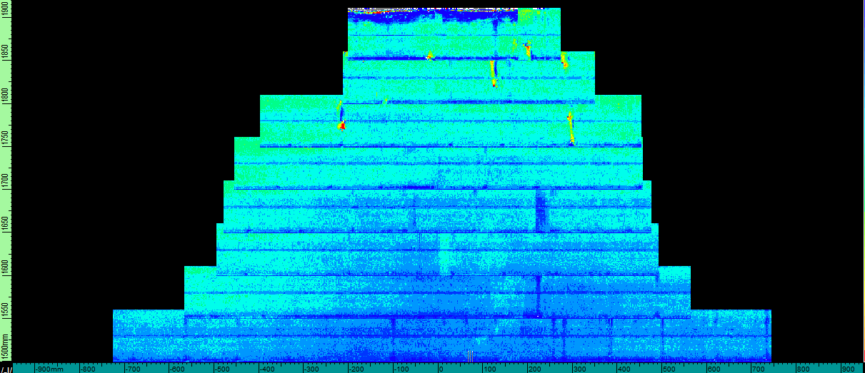

Y axis

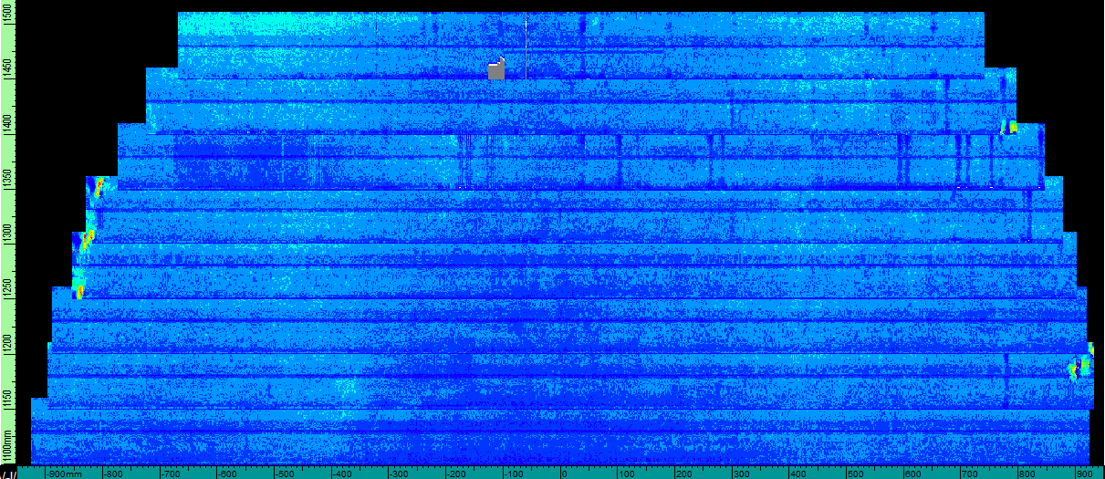 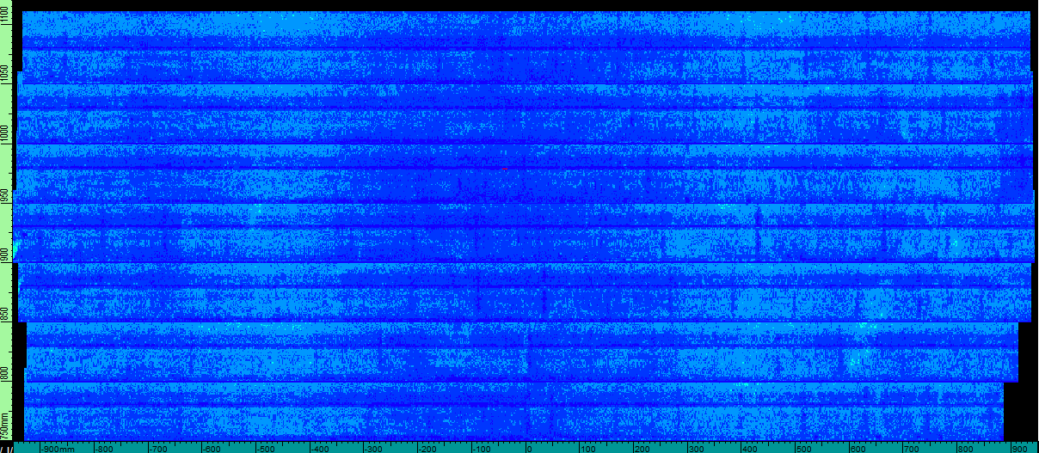

SOUTH

NORTH

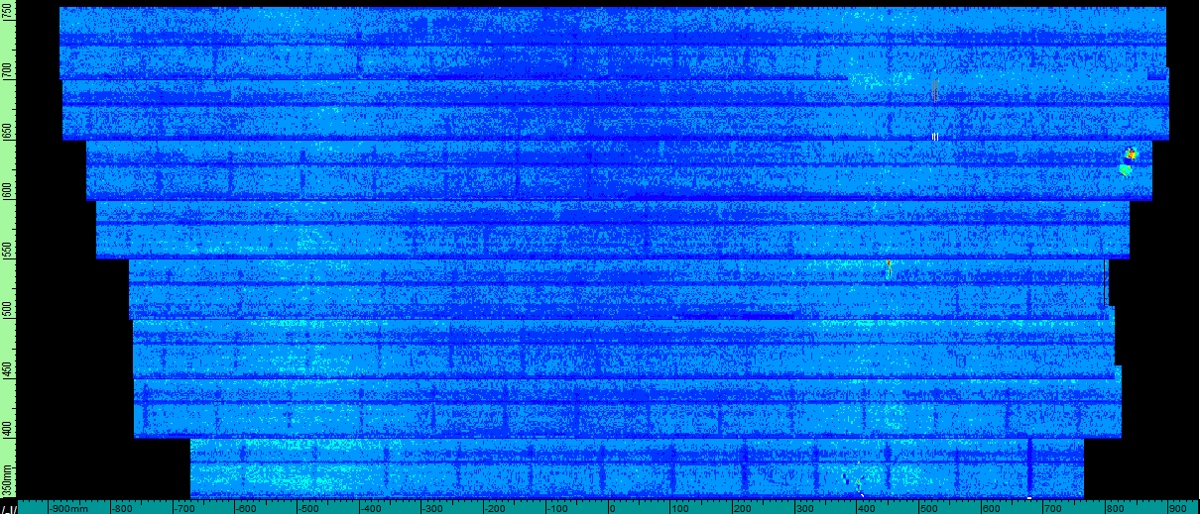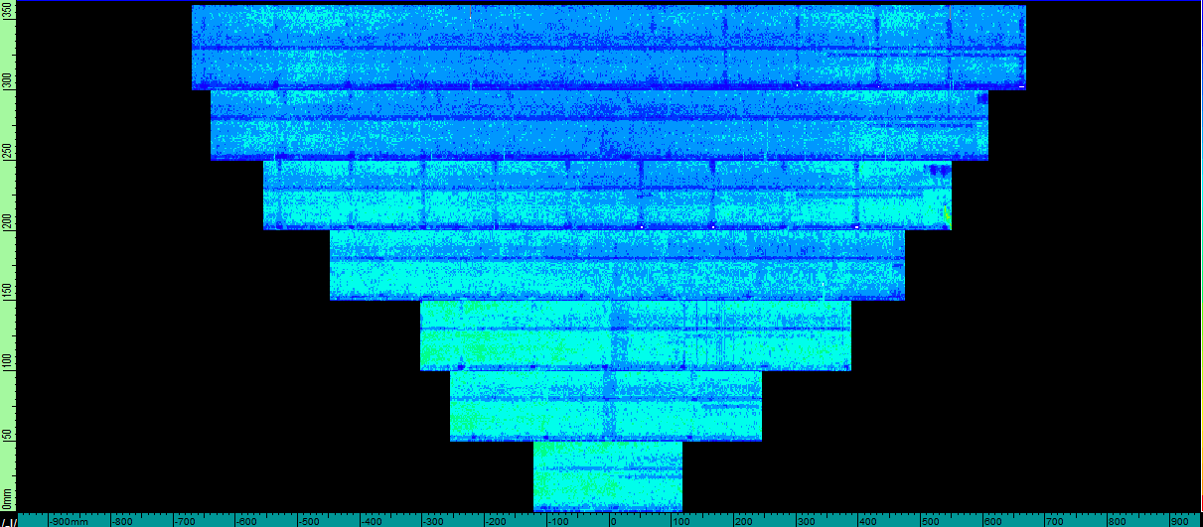

WEST